TravelPal User Manual

**Step 1 (Landing page):**

When in the landing page (after clicking the link), you can click any of the Navbar buttons at the top to go to their respective pages or scroll down to view the landing page sliders with more information. See Figure 7.1.

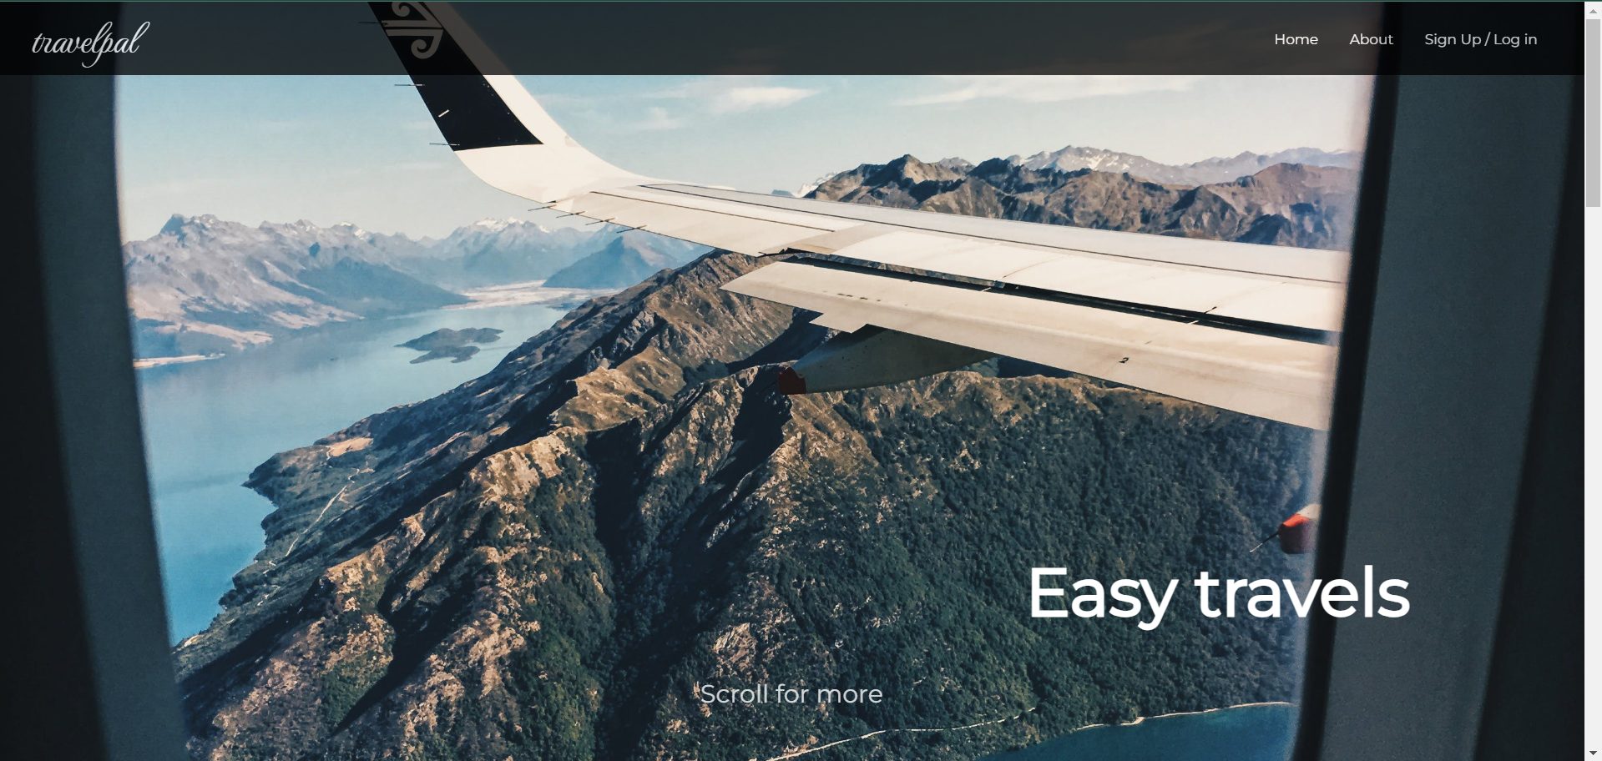

Figure 7.1 Landing Page

**Step 2 (Landing page scroll):**

As you scroll down, you will see images that fade in and out of the screen, prompting you to get started (see Figure 7.2). If you click the button, you will be re-directed to the Login page. You can observe that the webpage will not be refreshed as you are being re-directed throughout the application (a benefit of using React).

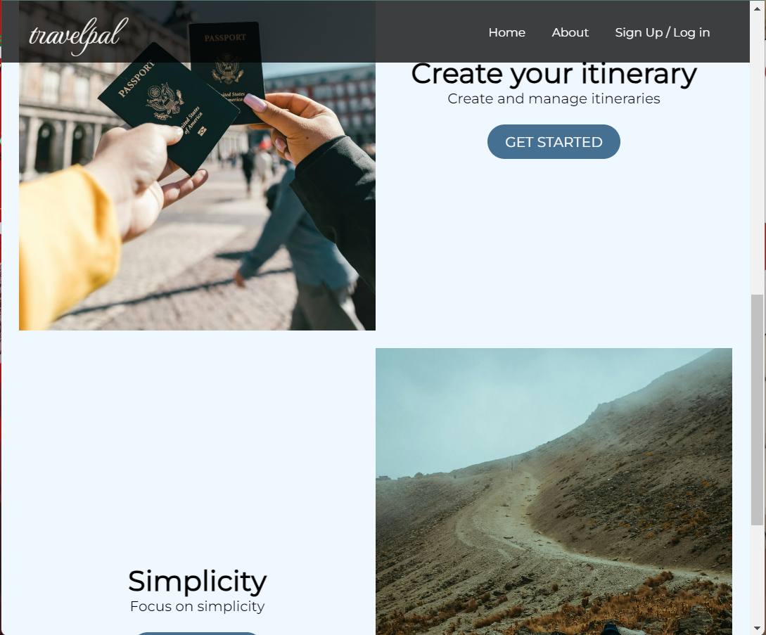

Figure 7.2 Landing Page Sliders

**Step 3 (Log In/Sign Up):**

In the Log In/Sign Up page, fill in your details and click the Log In or Sign Up button to Sign Up/Log In (see Figure 7.3). You will then be re-directed to your personal Dashboard.

Figure 7.3 Log In/Sign Up Page

**Step 4 (Dashboard):**

When logged in, you will see a Dashboard with your name on it. You will start with no itineraries but will have two options to get one. (Note: Click the Sign Out button on the Navbar at any point to sign out)

**Option 1:** Generate a sample itinerary, by clicking the blue button **outside** the “My itineraries” box. It will say “+ Sample Itinerary”.

**Option 2:** Create a new itinerary, by clicking the blue button **inside** the “My itineraries” box. It will say “Create New Itinerary” or “Create” if in mobile display.

Figure 7.4 Dashboard (no itineraries)

**Step 5 (Option 1: Sample Itinerary):**

If you click the sample itinerary button, a sample itinerary will be generated for you. You can use it for some inspiration. Clicking the itinerary preview, will display all the itinerary details (see Figure 7.8).

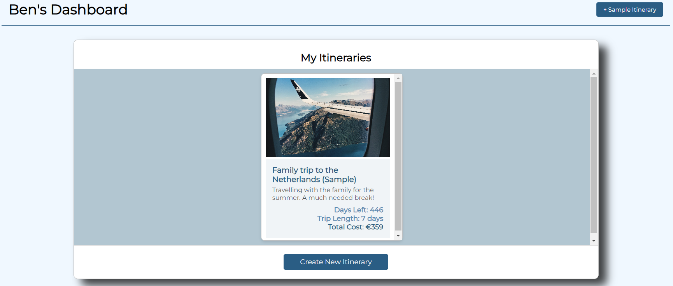

Figure 7.5 Dashboard (sample itinerary)

**Step 6 (Option 2: Create New Itinerary):**

Now that you have some inspiration, if you click the create button, a display will appear over the Dashboard for you to fill out your itinerary information.

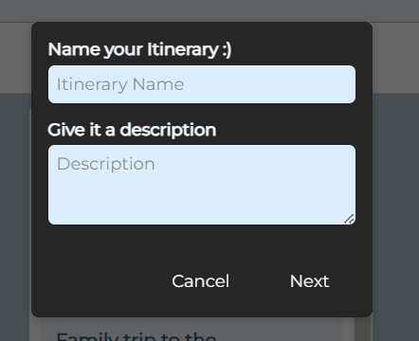

Figure 7.6 Dashboard (create itinerary)

**Step 7 (Add Activities):**

During the creation process, if you want to add an activity you will have to click the “Add Another Activity” button, then “expand activity”. From there, you can fill in the information for your Activity. Once all the itinerary is information is filled out and submitted, your new itinerary will be generated and stored in your “My Itineraries” list.

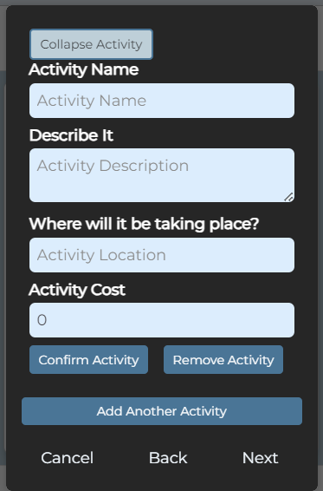

Figure 7.7 Dashboard (add activities)

**Step 8 (Itinerary Details):**

Upon clicking an Itinerary, you will be greeted with a display of all its details. Here you can close the itinerary or pick one of two options at the bottom of the details display.

**Option 1:** Click the red delete button to delete your itinerary.

**Option 2:** Click the green edit button to go through your itinerary and make changes of your choice.

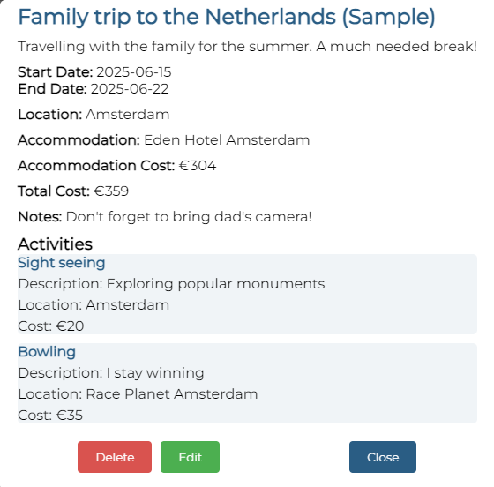

Figure 7.8 Dashboard (add activities)